Postings

LinkedIn
https://www.linkedin.com/feed/update/urn:li:ugcPost:6935443502348587008/
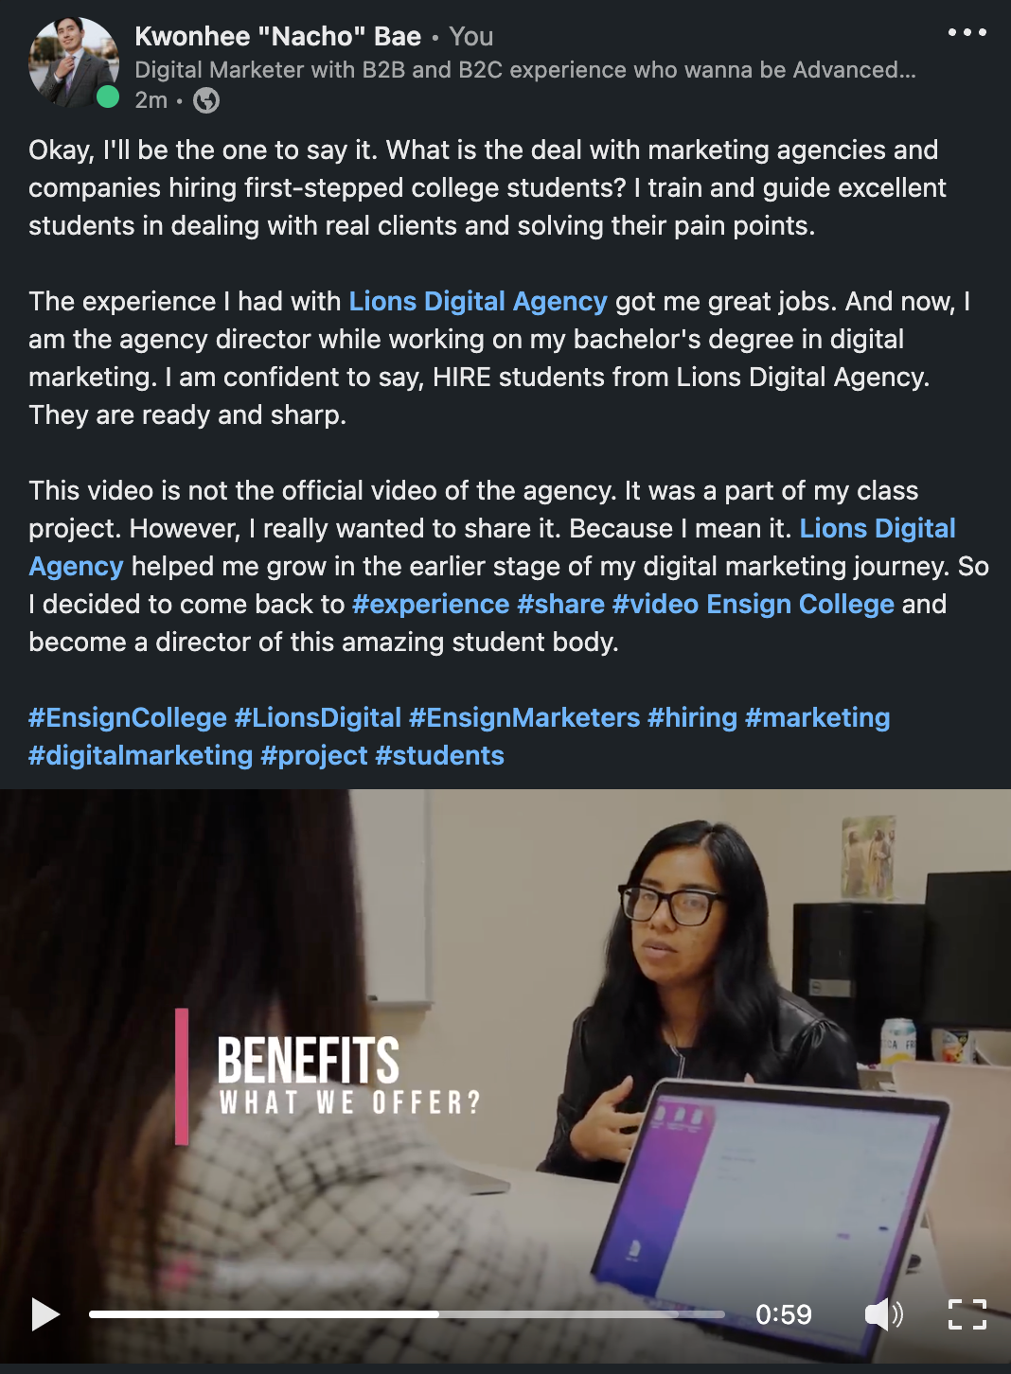

Facebook
https://www.facebook.com/100001534387916/videos/407024001320892/
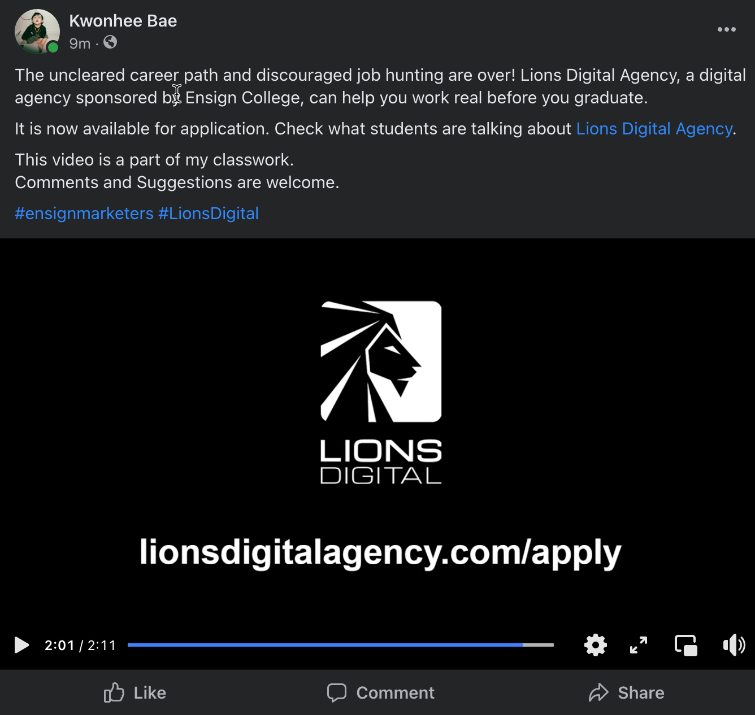

Stats

LinkedIn
- Qualitative Data: Answer these questions-
  - What went well?
      - Reached 364 people, 11 engagements, 3 comments, and 1 share
      - Cannot measure if it is successful without a specific performance indicator.
  - Who responded to it?
      - My previous colleague, my supervisor at work, Agency team members, and some data people.
  - What were typical comments?
      - Need to be more professional on the video.
  - Who shared it?
      - Lions Digital Agency Page

- Quantitative Data: Answer these questions-
  - How many times was it viewed?
      - 84 Views
  - How many responses did it receive?
      - A better quality video would be nice
  - When did the responses/shares/likes happen?
      - No data
  - Where were the most responses from?
      - Salt Lake City
  - Did you notice any patterns?
      - Not enough data
  - Viewer Demographics
      - The Church of Jesus Christ of Latter-Day Saints 8%
      - JourneyTEAM 8%
      - Ensign College 6%
      - eBay 3%
      - Goldman Sachs 3%

Facebook

- Qualitative Data: Answer these questions-
  - What went well?
      - Cannot measure if it is successful without a specific performance indicator.
  - Who responded to it?
      - Friends, colleagues, and people in a similar field.
  - What were typical comments?
      - 0 Comments
  - Who shared it?
      - 0 Shared
- Quantitative Data: Answer these questions-
  - How many times was it viewed?
      - 106 views
  - How many responses did it receive?
      - 16 people
  - When did the responses/shares/likes happen?
      - No data
  - Where were the most responses from?
      - 0 Comment
  - Did you notice any patterns?
      - No pattern was detected in the personal account. Needs to be a page to do it on Facebook.

